Changes to be made in homepage:
- Update logo
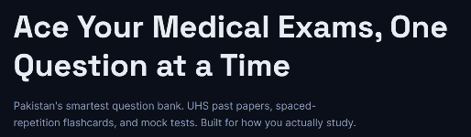
- Update the text below the First heading:
TEXT TO BE USED:
Pakistan’s smartest question bank, past papers, spaced-repetition flashcards, and high-yield mock tests, built around how you actually study.
- Change the order of buttons in header from features and how it works to:
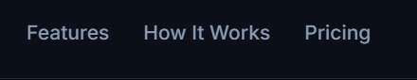
  - How it works
  - Features
  - Contact Us
- Edit the text in the try now button to:
TEXT TO BE USED: Try Practice Mode, It is Free!
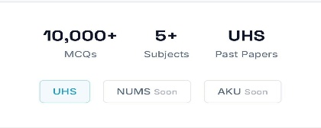
- Edit the section 2 of homepage:
  - 10,000+ MCQs
  - Change 5+ Subjects to: Smart Flash Cards
  - Change UHS past Papers to: High Yield Notes
  - remove aku, nums and uhs (bottom textboxes)
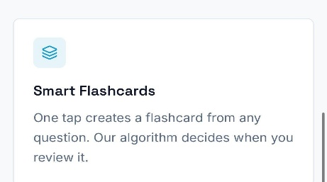
- Change the text in Smart Flashcards section:
TEXT TO BE USED:
One tap turns any question into a flashcard. Our algorithm surfaces it when you need it most, targeting your weak concepts.
- Add a link/button for Works everywhere section:
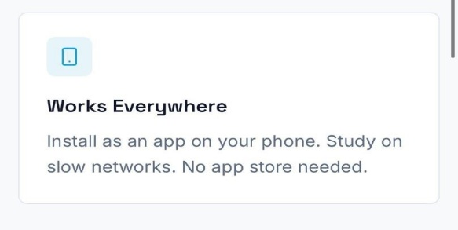
  - Add an option learn more that leads to a tutorial text showing how to install it as an app on ios and android. Do the same thing for “does it work on my phone” section.
- Archive or remove Built for every year section for now
- Archive or remove what students are saying section as well
- Make following changes to this FAQ ‘Which exams do you cover?’:
  - “At launch, our platform features high-yield content specifically for the UHS curriculum. However, we are in the process of rapidly expanding our database to include other examining bodies to support more medical students.”
  - Remove names like AKU NUMS and UCMD
- Make following changes to this FAQ ‘I found a mistake in question.
  - “Use report button on any MCQ, Flashcard or Notes. Our team regularly reviews all reports and ensures they’re corrected timely.”
- Change “Made for Pakistani medical students” to:
Clarity In Every Concept
Al-powered MCQs | Structured Notes | Flashcards
By Students, For Students
- Add a link for “contact us” page next to terms of service and privacy policy
  - for feeback/ queries: email us at support@medigify.com. (contact us page)

- Add an address and social links for Instagram and linkedin below the terms of service privacy policy and contact us button:
  - Add following address below terms of service and Privacy policy (Temporary requirement for swich to be removed later on after we receive payment gateway): “Boys Hostel, House # 1 Street 20, Shalimar Link Road, Lahore”
  - Social Links: Instagram:
    - Instagram: Instagram.com/Medigify
    - LinkedIn: https://www.linkedin.com/company/medigify
Changes to be made in sign-up page:
Errors: Login and Signup page not working giving error: Failed to fetch
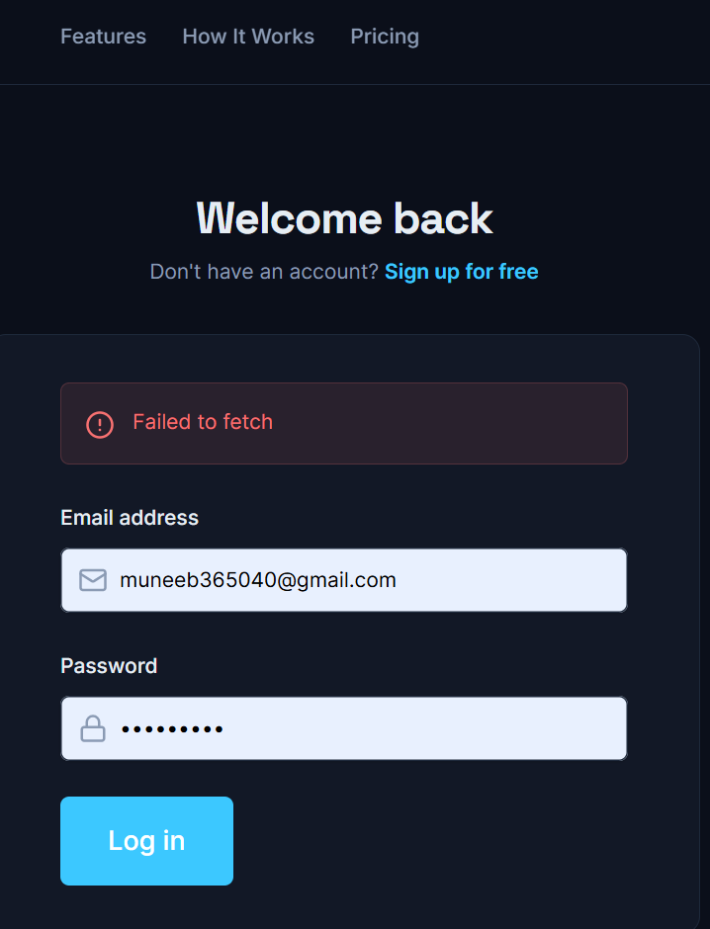
- Header remains same in login page but does not do anything, change it to take back to that section in homepage: For example when pressing features button in header at login page, only url changes to #features. Same issue in pricing page

  - Next to the field of examining body add following text in a pop up:
Medigify is currently optimized for the UHS curriculum. You are welcome to proceed if you would like to explore our resources and tools using this framework.
  - For Examining Bodies add following items (Alphabetical order) remove agha khan:
- Faisalabad Medical University (FMU)
- Fatima Jinnah Medical University (FJMU)
- King Edward Medical University (KEMU)
- National University Of Medical Sciences (NUMS)
- Nishtar Medical University (NMU)
- Rawalpindi Medical University (RMU)
- University College of Medicine and Dentistry (UCMD)
- University of Health Sciences (UHS)
- Other

  - Next to the field of study year in sign up, add following text in a pop up:
We are currently perfecting our First Year content library. Feel free to sign up and take a look around, we’re working hard to bring more years to the platform soon!
  - For College under examining body other than uhs add following:
- Faisalabad Medical University (FMU)
  - Faisalabad Medical University (Formerly Punjab Medical College), Faisalabad
- Fatima Jinnah Medical University (FJMU)
  - Fatima Jinnah Medical University, Lahore
- King Edward Medical University (KEMU)
  - King Edward Medical University, Lahore
- National University of Medical Sciences (NUMS)
  - Army Medical College (AMC), Rawalpindi
  - CMH Bahawalpur Institute of Medical Sciences (CIMS), Bahawalpur
  - CMH Kharian Medical College, Kharian
  - CMH Lahore Medical College & Institute of Dentistry, Lahore
  - CMH Multan Institute of Medical Sciences (CIMS), Multan
  - Fazaia Medical College, Islamabad
  - Fazaia Ruth Pfau Medical College, Karachi
  - Foundation University Medical College, Islamabad
  - HITEC Institute of Medical Sciences, Taxila
  - Karachi Institute of Medical Sciences (KIMS), Karachi
  - Quetta Institute of Medical Sciences (QIMS), Quetta
  - Wah Medical College, Wah Cantt
- Nishtar Medical University (NMU)
  - Nishtar Medical University, Multan
- Rawalpindi Medical University (RMU)
  - Rawalpindi Medical University, Rawalpindi
- University College of Medicine and Dentistry (UCMD)
  - University College of Medicine and Dentistry, Lahore
  - For Colleges under UHS use following list (alphabetical order) and add other in option as well:
- Akhtar Saeed Medical & Dental College, Lahore
- Allama Iqbal Medical College (AIMC), Lahore
- Ameer-ud-Din Medical College (AMC), Lahore
- Amna Inayat Medical College, Sheikhupura
- Avicenna Medical College, Lahore
- Bakhtawar Amin Medical & Dental College, Multan
- Central Park Medical College, Lahore
- D.G. Khan Medical College (DGKMC)
- FMH College of Medicine & Dentistry, Lahore
- Gujranwala Medical College (GMC)
- Khawaja Muhammad Safdar Medical College (KMSMC)
- Lahore Medical & Dental College (LMDC), Lahore
- Narowal Medical College, Narowal
- Nawaz Sharif Medical College (NSMC)
- Quaid-e-Azam Medical College (QAMC), Bahawalpur
- Rashid Latif Medical College, Lahore
- Sahiwal Medical College (SLMC)
- Sargodha Medical College (SMC)
- Services Institute of Medical Sciences (SIMS), Lahore
- Shaikh Khalifa Bin Zayed Al Nahyan Medical & Dental College (SKZMDC), Lahore
- Shalamar Medical & Dental College, Lahore
- Sharif Medical & Dental College, Lahore
- Sheikh Zayed Medical College (SZMC), Rahim Yar Khan
- Other
Changes to make on pricing page:
- Change following texts:
  - Secure & Private:
Your data is fully encrypted and securely stored, ensuring complete privacy and protection

  - Track Progress:
Get detailed insights into your performance, identify weak areas, and continuously improve with a clear, data-driven view.

  - Exam-Focused:
Carefully curated, high-yield questions designed specifically according to UHS exam patterns, helping you study smarter
- Remove last 2 features (study streak tracking and flashcard saving) from free plan.
